Introduction to Algorithms

Please complete all the below tasks using either pseudocode or Flowcharts and attach a screenshot of your completed algorithm.

**Student ID**: 103607174

**Full Name**: Pranil Shah

# Resources

1. https://www.mathsisfun.com/numbers/fibonacci-sequence.html

# Tasks

1. 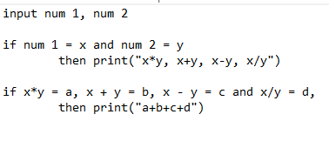Develop an Algorithm to accept 2 values from a user then display the sum of these values multiplied, summed, subtracted and divided by each other. Afterwards, display if the outputted value has a remainder.

Continued next page

1. Develop an Algorithm to generate and display the first 16 Fibonacci numbers. Attach a screenshot of your algorithm below. (You may submit either a Flowchart or Pseudocode)

1. Demonstrate and step though your Fibonacci algorithm with another student. Once the other student has understood your algorithm, please ask them to enter their name below.

By entering your Name you agree that you have had the owner of this document (as per the name above) demonstrate their understanding of the algorithm they have created.

**Name**: Phill